**ASSIGNMENT 3**

Name-Arjun tyagi

Prn-21070126020

Class-AIML A1

Question-Write a menu-driven Java Program to study the concepts of classes, array  
of objects/arraylist, instance members, constructors in java.  
Assignment description: Create a Student class describing attributes of a  
student like prn, name, DoB, marks etc. Create an array of objects of  
Student class and perform operations like: Add students, Display, Search  
(by prn, by name, by position), Update/Edit and Delete.

import java.util.*;

public class Assignment_3_ArrayList {

public static void main(String[] args)

{

student_functions student_functions_object = new student_functions();

// menu for add, display, search, update, delete

while(true){

System.out.println("Select the operation to modify database: ");

System.out.println("0. Exit");

System.out.println("1. Add student details");

System.out.println("2. Display all");

System.out.println("3. Search student");

System.out.println("4. Update Details");

System.out.println("5. Delete record");

Scanner sc = new Scanner(System.in);

int choice = sc.nextInt();

switch(choice){

case 0:

System.out.println("Exiting...");

break;

case 1:

student_functions_object.add_student();

break;

case 2:

student_functions_object.display();

break;

case 3:

student_functions_object.search();

break;

case 4:

student_functions_object.update();

break;

case 5:

student_functions_object.delete();

break;

default:

System.out.println("Invalid choice");

}

if(choice==0){

break;

}

}

}

}

class student {

private int prn;

private String name;

private String dob;

private int marks;

public student(int prn, String name, String dob, int marks) {

this.prn = prn;

this.name = name;

this.dob = dob;

this.marks = marks;

}

public int getPrn() {

return prn;

}

public void setPrn(int prn) {

this.prn = prn;

}

public String getName() {

return name;

}

public void setName(String name) {

this.name = name;

}

public String getDob() {

return dob;

}

public void setDob(String dob) {

this.dob = dob;

}

public int getMarks() {

return marks;

}

public void setMarks(int marks) {

this.marks = marks;

}

}

class student_functions {

ArrayList<student> student_list = new ArrayList<student>();

public void print_student(int i)

{

System.out.print("Name: " + student_list.get(i).getName()+" | ");

System.out.print("PRN: " + student_list.get(i).getPrn()+" | ");

System.out.print("DOB: "+ student_list.get(i).getDob()+" | ");

System.out.print("Marks: " +student_list.get(i).getMarks()+" | \n\n");

}

public void add_student() {

Scanner sc = new Scanner(System.in);

System.out.println("Enter the number of students to be added: ");

int n = sc.nextInt();

for (int i = 0; i < n; i++) {

System.out.println("Enter the details of the student in the following format: PRN, Name,

Date of Birth (dd/mm/yyyy), Marks");

String details = sc.next();

String[] details_array = details.split(",");

int prn = Integer.parseInt(details_array[0]);

String name = details_array[1];

String dob_string = details_array[2];

int marks = Integer.parseInt(details_array[3]);

student new_student = new student(prn, name, dob_string, marks);

student_list.add(new_student);

}

}

public void display() {

for (int i = 0; i < student_list.size(); i++) {

print_student(i);

}

}

public void search(){

System.out.println("Select the search criteria: ");

System.out.println("1. PRN");

System.out.println("2. Name");

System.out.println("3. Position");

Scanner sc = new Scanner(System.in);

int choice = sc.nextInt();

switch(choice){

case 1:

// //Using contains method

// System.out.println("Enter the PRN to be searched: ");

 // int temp_prn = sc.nextInt();

// if(student_list.contains(temp_prn)){

// int found = student_list.indexOf(temp_prn);

// print_student(found);

// }

// else{

// System.out.println("PRN not found");

// }

//OR

System.out.println("Enter the PRN to be searched: ");

int prn = sc.nextInt();

for (int i = 0; i < student_list.size(); i++) {

if (student_list.get(i).getPrn() == prn) {

print_student(i);

}

}

break;

case 2:

System.out.println("Enter the Name to be searched: ");

String name = sc.next();

for (int i = 0; i < student_list.size(); i++) {

if (student_list.get(i).getName() == name) {

print_student(i);

}

}

break;

case 3: //position

System.out.println("Enter the Position to be searched: ");

int position = sc.nextInt();

for (int i = 0; i < student_list.size(); i++) {

if (i == position) {

print_student(i);

}

}

break;

default:

System.out.println("Invalid choice");

}

}

public void update(){

System.out.println("Enter the PRN of the student to be updated: ");

Scanner sc = new Scanner(System.in);

int prn = sc.nextInt();

for (int i = 0; i < student_list.size(); i++) {

if (student_list.get(i).getPrn() == prn) {

System.out.println("Enter the details of the student in the following format: PRN, Na

me, Date of Birth (dd/mm/yyyy), Marks");

String details = sc.next();

String[] details_array = details.split(",");

int prn_new = Integer.parseInt(details_array[0]);

String name_new = details_array[1];

String dob_string_new = details_array[2];

int marks_new = Integer.parseInt(details_array[3]);

student new_student = new student(prn_new, name_new, dob_string_new, marks_new);

student_list.set(i, new_student);

}

}

}

public void delete(){

System.out.println("Enter the PRN of the student to be deleted: ");

Scanner sc = new Scanner(System.in);

int prn = sc.nextInt();

for (int i = 0; i < student_list.size(); i++) {

if (student_list.get(i).getPrn() == prn) {

System.out.println("Student named:"+ student_list.get(i).getName() + " deleted succes

sfully");

student_list.remove(i);

}

}

}

}

**OUTPUT**

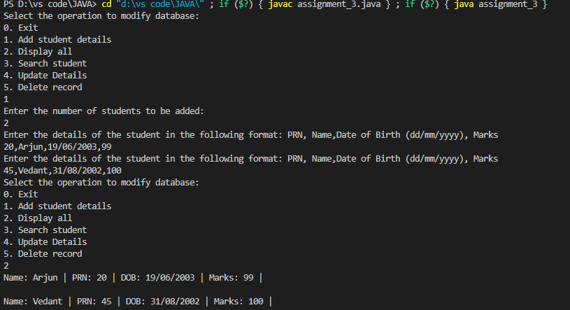

**GITHUB LINK**

[**https://github.com/arjuntyagi19/java_assignment**](https://github.com/arjuntyagi19/java_assignment)